Microsoft Azure IoT Express

**INSTRUCTOR INFORMATION**

Loy Vanich



084 007 5544

facebook

[facebook.com/laploy](https://www.facebook.com/laploy)

Line ID: laployv

laploy@gmaill.com

www.laploy.com

**TIME FRAME**

* Course duration
* Start time
* Coffee break
* Lunch break
* Course end
* Parking

facebook message group setting

* to share code
* to share photo
* to share links

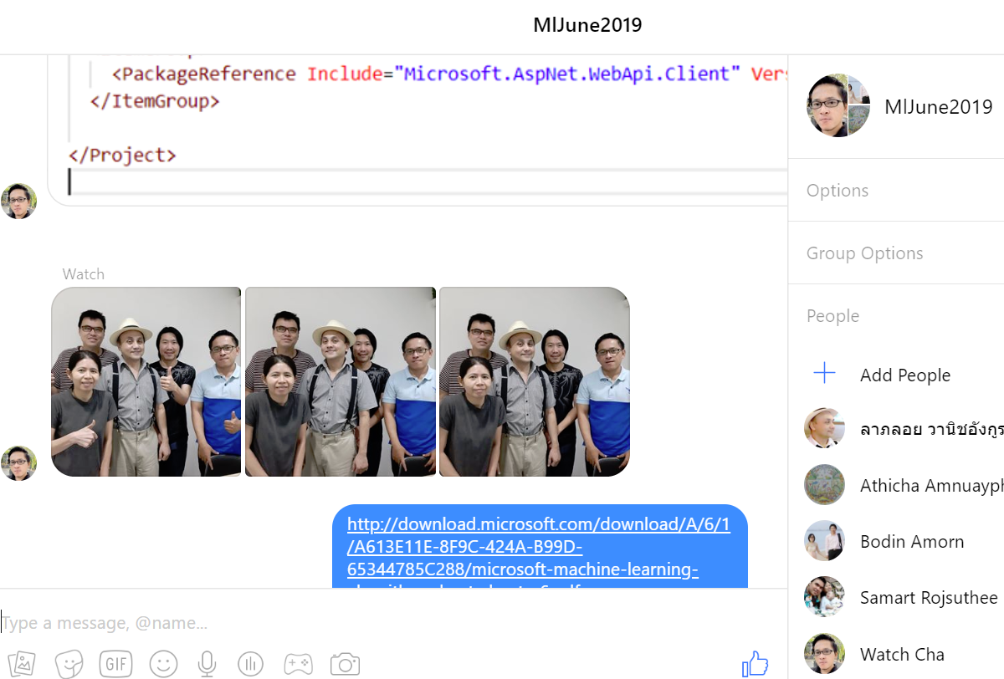

Useful URLs

Course Home Page

<https://github.com/laploy?tab=repositories>

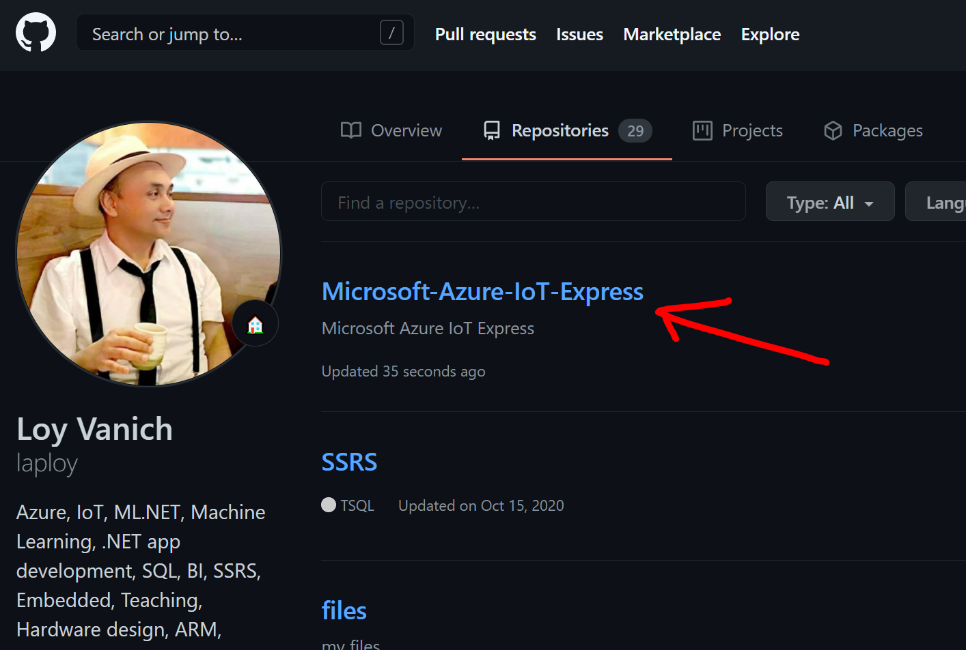

Useful URLs

Microsoft Azure Machine Learning Studio landing page

studio.azureml.net

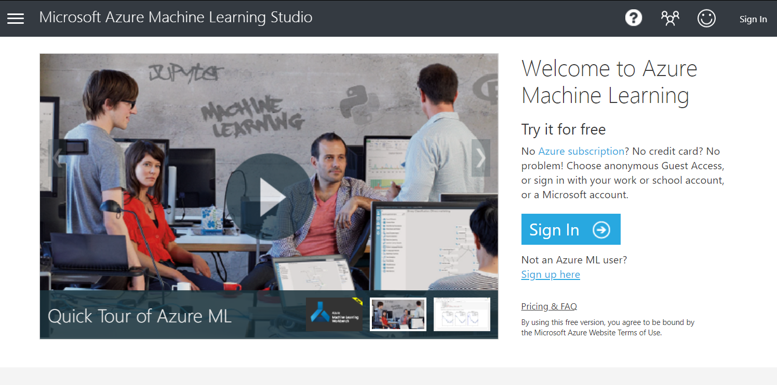

Useful URLs

Microsoft Azure Portal

https://portal.azure.com/#home

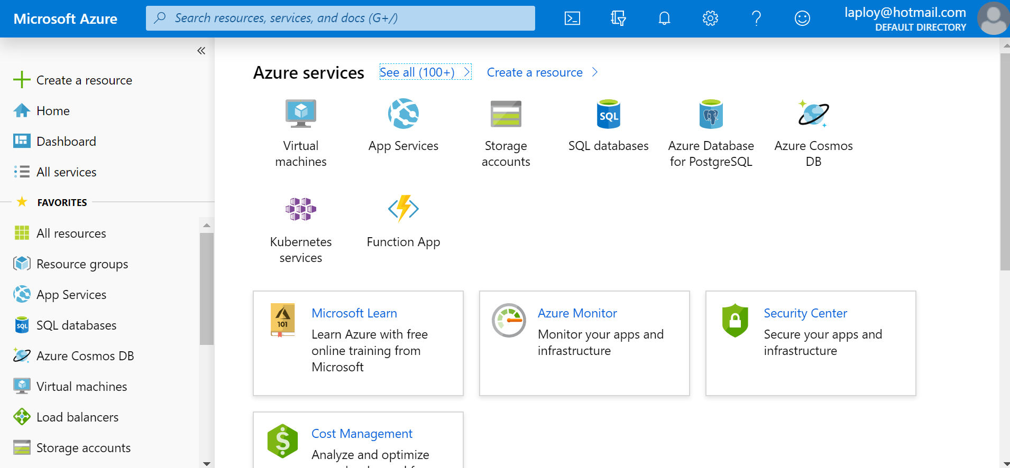

Evaluation Form

https://bit.ly/gfbiz-eval

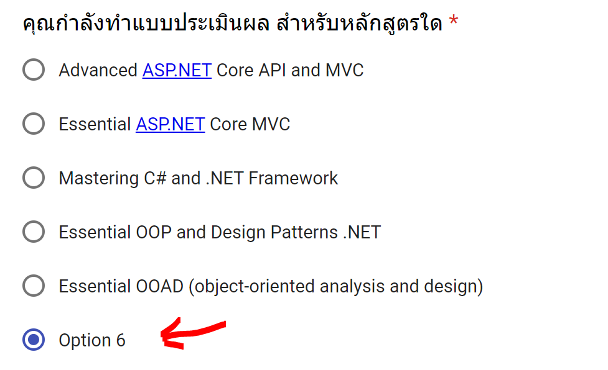

Technology to use



ML.NET

Azure IoT

Microsoft Power BI

Course outline

* What is IoT
* Setting up development environment
* Getting started with Microsoft Azure IoT suite
* Creating Microsoft Azure IoT hub
* Creating a device identity
* Creating device simulator
* Simulating Device-to-Cloud data telemetry
* Microsoft Azure Event Hub overview
* Creating Microsoft Azure Event Hub
* Sending messages to Microsoft Azure Event Hubs
* Alarm and response
* Microsoft Azure Service Bus
* Sending Command to Simulator
* Responding to acknowledgement